

Requirement & Design Specification
Global Assess Management System (GAMS)
Version: 1.0

– Hanoi, August 2022 –

Record of Changes
Version | Date | A*  M, D | In charge | Change Description
V1.0 | 15/2 | A | KienNTHE11
*A - Added M - Modified D - Deleted

Contents
Record of Changes 2
I. Overview 4
1. User Requirements 4
1.1 Actors 4
1.2 Use Cases 4
2. System Functionalities 5
2.1 Screens Flow 5
2.2 Screen Authorization 5
2.3 Non-UI Functions 6
3. High Level Design 6
3.1 Database Design 6
3.2 Code Packages 7
II. Functional Requirements 8
1. <<Feature Name1>> 8
1.1 <<Screen/Function Name1>> 8
1.2 User Login 8
1.3 … 8
2. System Administration 8
2.1 System Settings 8
2.2 … 9
3. … 9
III. Detailed Designs 9
1. <Feature/Function Name1> 9
1.1 Class Diagram 9
1.2 Sequence Diagram(s) 10
1.3 Database Queries 10
2. <Feature/Function Name2> 10

I. Overview

1. User Requirements

1.1 Actors
[An actor is someone/something that interacts with the system.
- The only external entities that interact with the system
- ﻿Actors are outside the system and not part of it
- ﻿A user is an individual, whereas an actor represents the role played by all users of the same type
- There are other types of actors in addition to or in place of human actors: external systems, I/O devices, or timers
Following are some questions you might ask to help user representatives identify actors
- Who (or what) is notified when something occurs within the system?
- Who (or what) provides information or services to the system?
- Who (or what) helps the system respond to and complete a task?
This part gives the description of system actors, you can follow the table form as below]
# | Actor | Description
1 | Administrator | Actor description here..
2 | Menu Manager | ..
3 | …

1.2 Use Cases
[A use case (UC) describes a sequence of interactions between a system and an external actor that results in the actor being able to achieve some outcome of value. The names of use cases are always written in the form of a verb followed by an object. Select strong, descriptive names to make it evident from the name that the use case will deliver something valuable for some user.
Following are some questions you might ask to help user representatives identify use cases
- What will the actor use the system for?
- Will the actor create, store, change, remove, or read data in the system?
- Will the actor need to inform the system about external events or changes?
- Will the actor need to be informed about certain occurrences in the system?
In this section, you need to provide the UC diagram(s) to show the actor-UCs and UC-UC relationships like the sample below. You can have multiple UC diagrams for the system, each diagram is for one actor or one workflow]

1.2.1 UCs for Guest
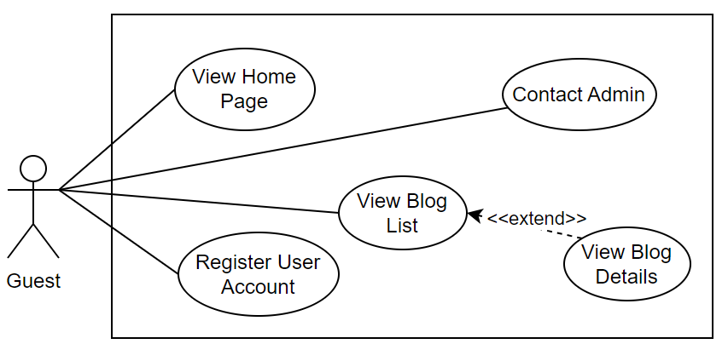

1.2.2 UCs for Student
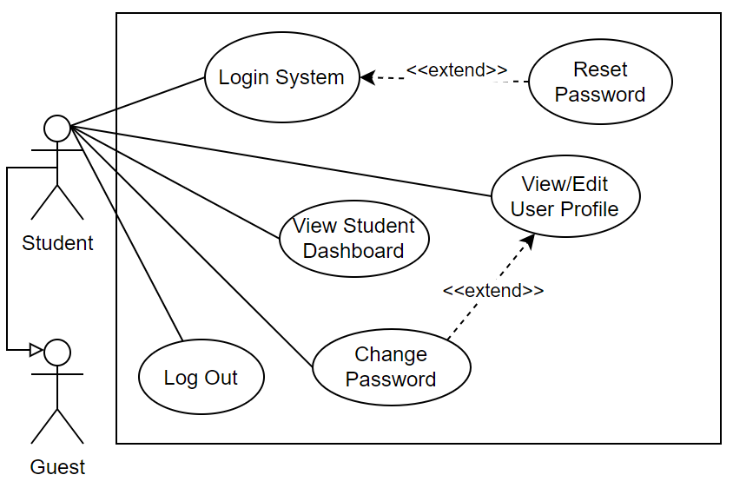

1.2.3 …

2. System Functionalities
[Provide functionality overview of software system: screen flow, screen descriptions, system user roles, screen authorization, non-screen functions, ERD]

2.1 Screens Flow (Trong Screen Flow, mỗi "screen" là một màn hình chức năng)
[This part shows the system screens and the relationship among screens. You can draw the Screens Flow for the system in the form of diagram as below.]
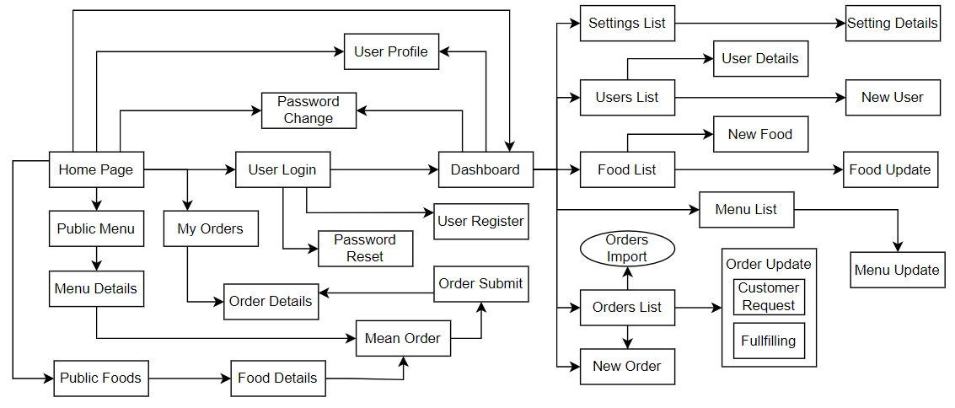

2.2 Screen Authorization
[Provide the system roles authorization to the system features (down to screens, and event to the screen activities if applicable) in the table form as below – replace Role-Name1, Role-Name2,… with your specific system user role names]
Screen | Role-Name1 | Role-Name2 | Role-Name3 | …
<<Screen Name1>> | X |  | X | X
<<Screen Activity>> |  |  | X | X
<<Screen Name2>> | X |  | X
Query All Data | X
Query Own Data |  |  | X
Add New Data |  |  | X | X
Update All Data |  |  |  | X
Update Own Data |  |  |  | X
Delete Data
…

2.3 Non-UI Functions
[Provide the descriptions for the non-screen system functions, i.e batch/cron job, service, API, etc.]
# | Feature | System Function | Description
1 | <<Feature Name>> | <<Function Name1>> | <<Function Name1 Description>>
2 | …

3. High Level Design

3.1 Database Design
[Provide the tables relationship like example below]

3.1.1 Database Schema
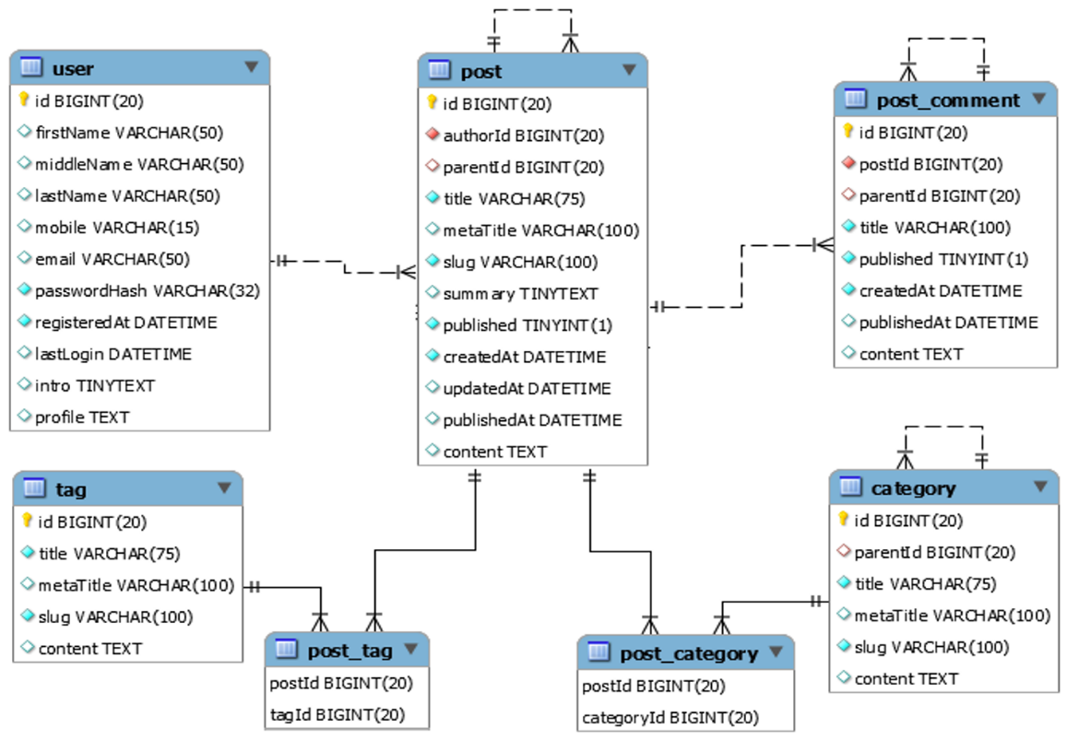

3.1.2 Table Descriptions
No | Table | Description
01 | <Table name> | <Description of the table>  - Primary keys: <<list of primary key fields>>  - Foreign keys: <<list of foreign key fields>>  - Unique keys:<<list of unique field or unique field set>>
02 | <Table name2> | …

3.2 Code Packages
[Provide the package diagram for the system (or sub systems) and package description similar to sample diagram and using description table format below]

3.2.1 Package Diagram
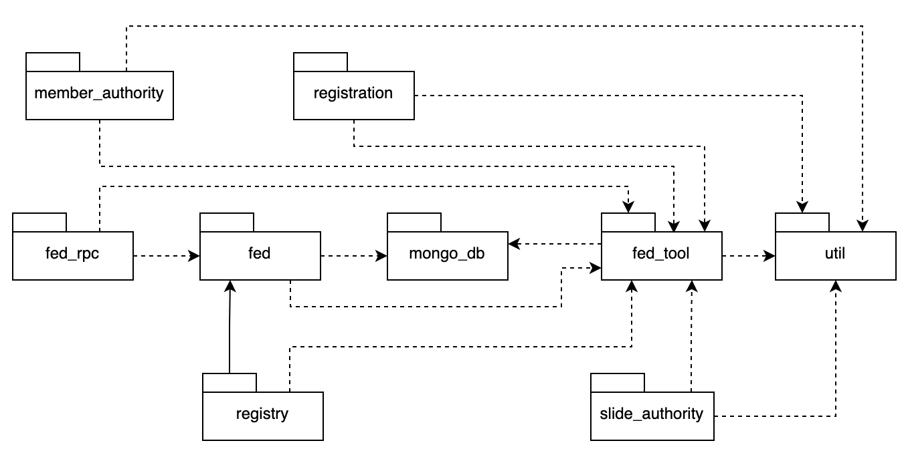

3.2.2 Package Descriptions
No | Package | Description
01 | member_authority | <Description of the package: purpose, contents,..>
02 | registration | <Description of the package: purpose, contents,..>
03 | …

II. Functional Requirements
[Provide descriptions about the system’s functions/screens. The functions/screens are grouped by the system features, and even sub-features if needed. For the screens, you need to provide the screen layouts (mock-up screens) and relevant specifications if needed]

1. <<Feature Name1>>

1.1 <<Screen/Function Name1>>
[Screen/Function description]
[Screen layout(s)]
[Screen specifications: field initializations, the showing/hiding of some fields, etc.]

1.2 User Login
This screen allows user to be authenticated to the system screens/functionalities.
S1_User Login screen | S2_Select account to login (with Google)
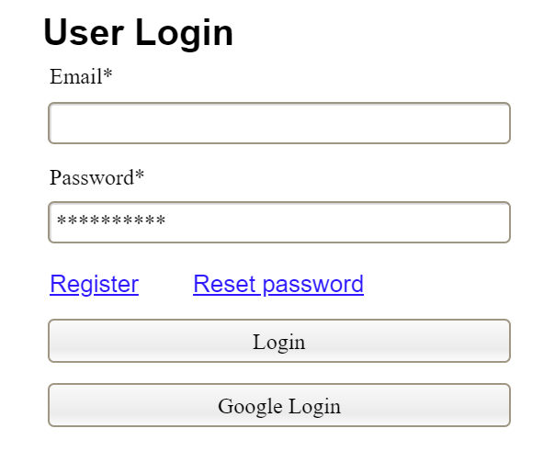 | 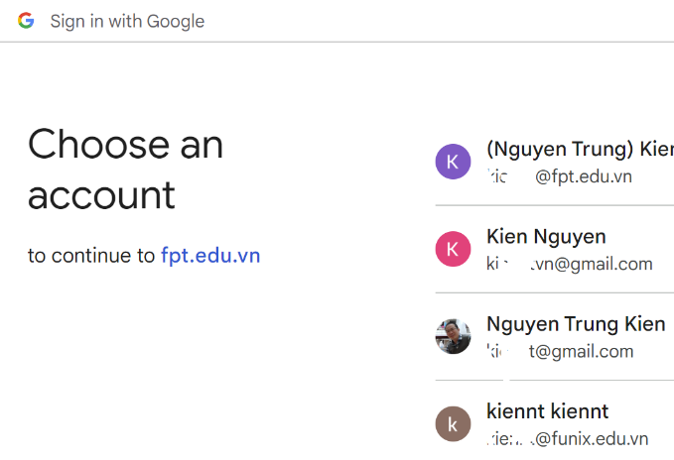

1.3 …

2. System Administration

2.1 System Settings

2.1.1 Setting List
This is for the administrator to view the list of current system settings. On the screen, s/he can also activate or deactivate (change status) of a specific setting.
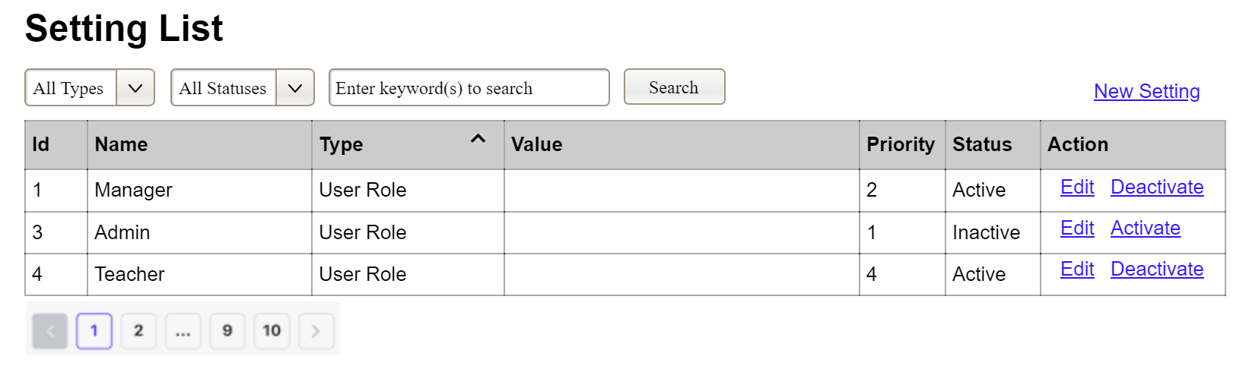
(2)
(3)
(1)
(1) Setting Type:
- Initialized with all the active setting types filled in,
- Allow user to filter the setting list by a specific setting type
- Default value is “All Types”, allowing user to see the settings at all types
(2) Setting Status:
- Initialized with two values Active and Inactive filled in
- Allow user to filter the setting list by a specific status (Active or Inactive)
- Default value is “All Types”, allowing user to see the settings at all statuses
(3) The change-status action is Activate or Deactivate depending on the current status of the relevant setting (Inactive or Active, respectively). The user needs to confirm the status changing via a modal confirmation message before getting that done.

2.1.2 Setting Details
This is for the administrator to add new or view/update an existing system setting
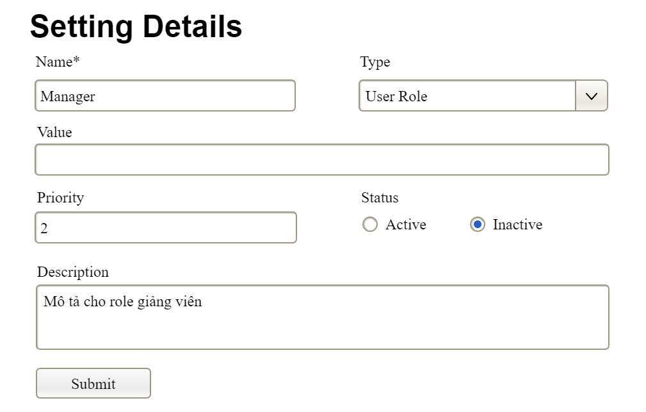

2.2 …

3. …

III. Detailed Designs

1. <Feature/Function Name1>
[Provide the detailed design for the function <Feature/Function Name1>. It includes class diagram and sequence diagram(s)]

1.1 Class Diagram
[This part presents the class diagram for the relevant feature]
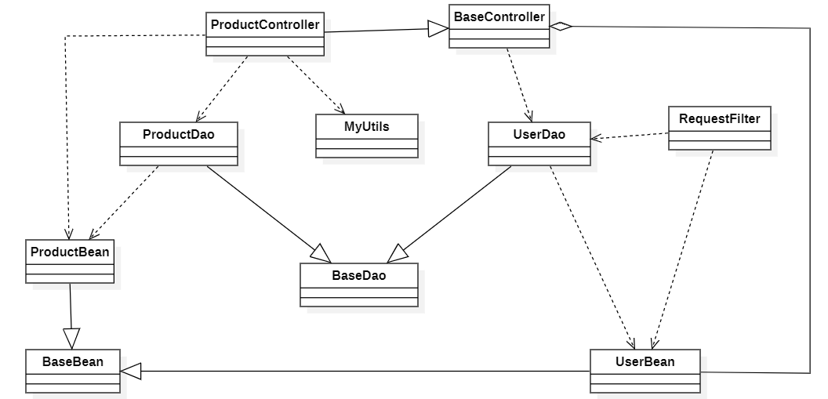

1.2 Sequence Diagram(s)
[Provide the sequence diagram(s) for the feature/function, see the sample below. Sequence diagrams with similar message flow can be omitted, but you need to mention the appropriate reference to the similar sequence diagram]
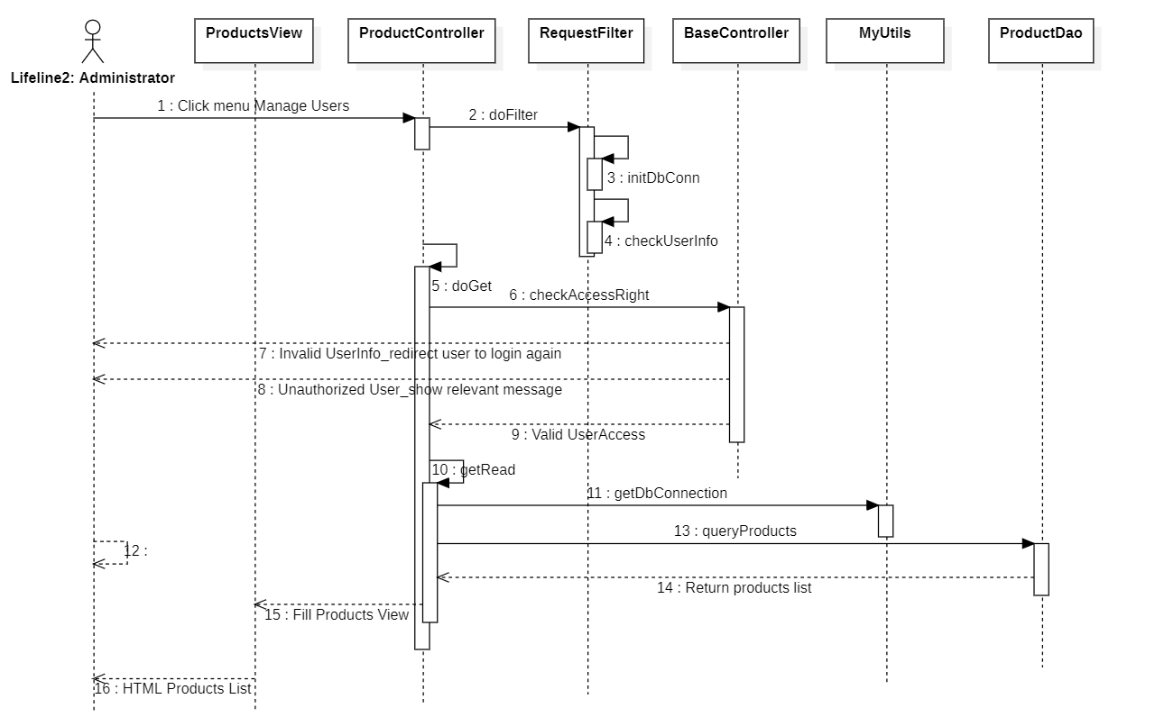

1.3 Database Queries
[Provide the detailed SQL (select, insert, update...) which are used in implementing the function/screen]

2. <Feature/Function Name2>
…

